RELIABLE OUTBOX PATTERNS
Contents
RELIABLE OUTBOX PATTERNS 3
8. The dual-write problem 3
Failure case A: DB succeeds, event is lost 3
Failure case B: event succeeds, DB fails 3
9. Transactional Outbox Pattern 3
Does Outbox provide exactly-once publication? 4
10. Idempotent consumers and the Inbox pattern 5
Atomic deduplication 5
11. Retry policy 6
Transient failures 6
Permanent failures 6
Exponential backoff and jitter 6
12. Dead-Letter Queue (DLQ) 7
13. Saga Pattern 7
14. Event versioning 8
15. Concrete Stridge-style failure scenario 9
16. critical concepts 9

RELIABLE OUTBOX PATTERNS
Kafka introduces another problem: a service (as a producer of event) can need to update its own database and publish an event. Those are two independent writes, and failures between them can make systems disagree.

8. The dual-write problem
Suppose a settlement completes. The service must update its database and publish in the SettlementCompleted topic for consumers.
A. UPDATE settlements
status = completed
B. publish:
SettlementCompleted

A naive implementation performs the database update and then publishes to Kafka. That appears correct until the process fails between those two operations.

Failure case A: DB succeeds, event is lost
UPDATE DB
|
SUCCESS
|
process crashes
|
Kafka publish never happens

The database says COMPLETED, while Kafka contains no SettlementCompleted event. Analytics, webhooks, and other consumers never learn what happened.

Failure case B: event succeeds, DB fails
publish Kafka
|
SUCCESS
|
DB update fails

Consumers believe SettlementCompleted, while the authoritative settlement database still says PENDING. The two systems disagree.
DEFINITION: This is the dual-write problem: one logical business operation needs two writes that are not automatically atomic together.

9. Transactional Outbox Pattern
Transactional Outbox avoids directly coupling the business transaction to a Kafka publish. Instead, the service writes both the business state and a pending event into the same local database transaction.
BEGIN DATABASE TRANSACTION
UPDATE settlements
SET status = 'completed'
INSERT INTO outbox (
event_id,
type,
payload
)
COMMIT

Because both writes use one database transaction, either both commit or both roll back.
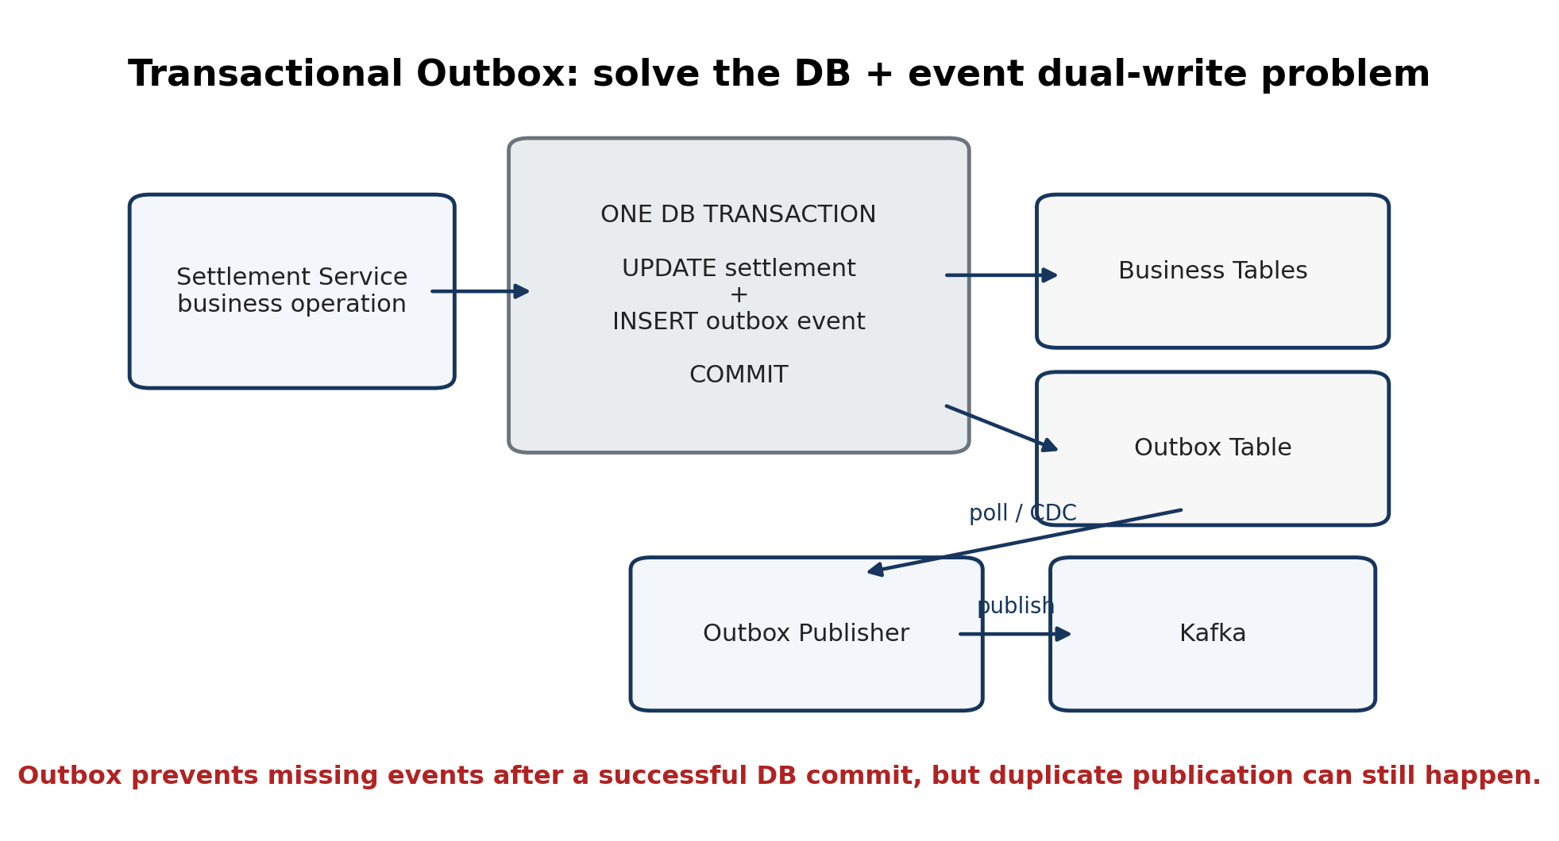
Figure 5. Business state and the pending event commit atomically; a separate publisher later sends the event to Kafka.

Does Outbox provide exactly-once publication?
No. The outbox publisher can publish an event successfully, crash before marking the outbox row as sent, restart, and publish the same event again.
1. publish event to Kafka
2. Kafka accepts it
3. publisher crashes
4. outbox row was not marked sent
5. publisher restarts
6. event is published again

VERY IMPORTANT: Outbox prevents a commited DB change without it’s corresponding event. It does not guarantee that duplicate event publication can never happen.

10. Idempotent consumers and the Inbox pattern
If event evt_123 is delivered twice, business logic must not execute twice. A payment or credit consumer cannot safely assume each event arrives only once.
evt_123 -> credit user $100
evt_123 -> credit user another $100 # WRONG

One approach is to store processed event IDs:
processed_events
event_id
---------
evt_123
evt_456

When evt_123 arrives again, the consumer sees that it has already been processed and ignores it safely.

Inbox Pattern
A stronger design (just like the atomic outbox change) records the event ID and performs the business update (consumer DB change) in the same local transaction:
BEGIN
INSERT INTO processed_events(event_id)
UPDATE user_balance ...
COMMIT

A UNIQUE constraint on event_id prevents the duplicate delivery from repeating the business action.
This receive-side pattern is often called an Inbox pattern.
PAIR TO REMEMBER: Outbox = reliably send events. Inbox / idempotent consumer = safely receive duplicate-prone events.

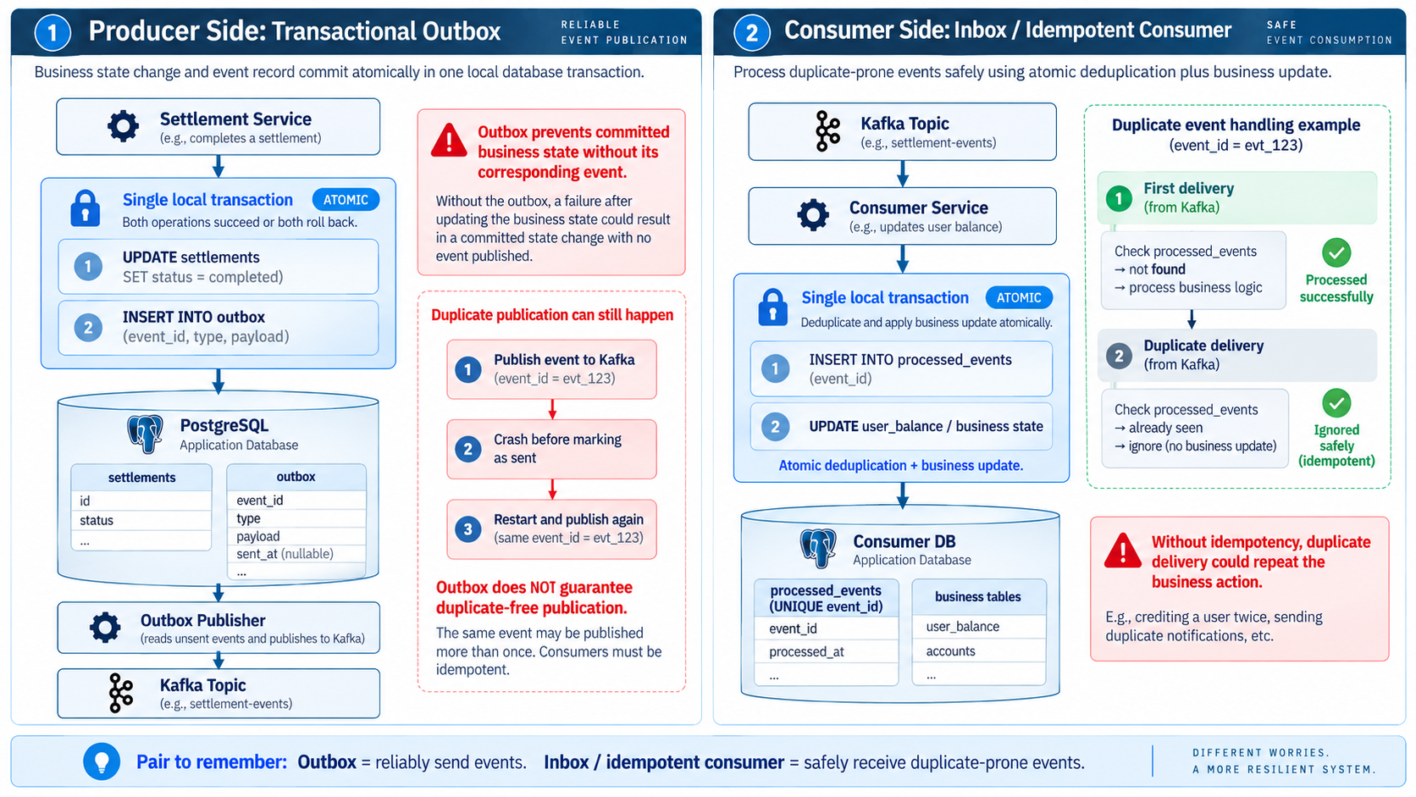

11. Retry policy
Retries should distinguish transient failures from permanent failures.

Transient failures
- timeout
- HTTP 429 rate limit
- HTTP 503 unavailable
- temporary database or network issue
These may recover, so retry can make sense.

Permanent failures
- invalid address
- malformed payload
- unsupported asset
- authentication denied
- business rule violation
These usually will not become valid by retrying forever.

Exponential backoff and jitter
A healthy retry schedule increases delays between attempts rather than retrying continuously.
retry #1 -> wait ~1s
retry #2 -> wait ~2s
retry #3 -> wait ~4s
retry #4 -> wait ~8s

If thousands of clients follow the exact same schedule, they can hit a recovering dependency in synchronized waves. Jitter randomizes each delay:
client A -> 4.2 seconds
client B -> 5.1 seconds
client C -> 3.7 seconds
client D -> 4.6 seconds

This reduces the thundering-herd effect.
RELIABILITY COMBINATION: Retry + idempotency + exponential backoff + jitter.

12. Dead-Letter Queue (DLQ)
A repeatedly failing event (for example KYT receives an event saying an address made a transaction, tries to analyze/flag it, but processing keeps failing. Without a DLQ, the consumer may keep retrying that same event and delay later events.) should not permanently block or destabilize the main processing pipeline. After the configured retry policy is exhausted, the event can be moved to a dead-letter queue for later inspection or replay.
kyt-events
|
v
consumer
|
+-- success -> done
|
+-- repeated failure
|
v
kyt-events-dlq

A DLQ is not a garbage bin. Preserve enough context to diagnose the failure:
- original event
- error
- attempt count
- timestamp
- correlation ID

13. Saga Pattern
A business workflow can span several services and external systems that cannot participate in one database transaction.
1. Reserve balance
2. Create settlement
3. Execute bridge
4. Notify destination

A normal BEGIN/COMMIT transaction cannot atomically cover Wallet DB, Settlement DB, an external bridge provider, and a blockchain.
Saga models the overall business operation as a sequence of local transactions. If a later step fails, compensating actions are used where possible.
Reserve funds
|
Create settlement
|
Bridge execution fails
|
release/refund reserved funds

Two broad styles:
- Choreography: services react to events.
- Orchestration: a central workflow/orchestrator tells services what step to perform.
At this stage, understand the problem Saga solves; do not study Saga frameworks.

14. Event versioning
Events are contracts between services and therefore need careful schema evolution.
Today:
{
"type": "DepositConfirmed",
"address": "...",
"amount": "100"
}
Later:
{
"type": "DepositConfirmed",
"address": "...",
"amount": "100",
"network_id": 1
}

Old consumers may still be running, so payload changes must be compatible or explicitly versioned.
{
"event_type": "deposit.confirmed",
"event_version": 2
}

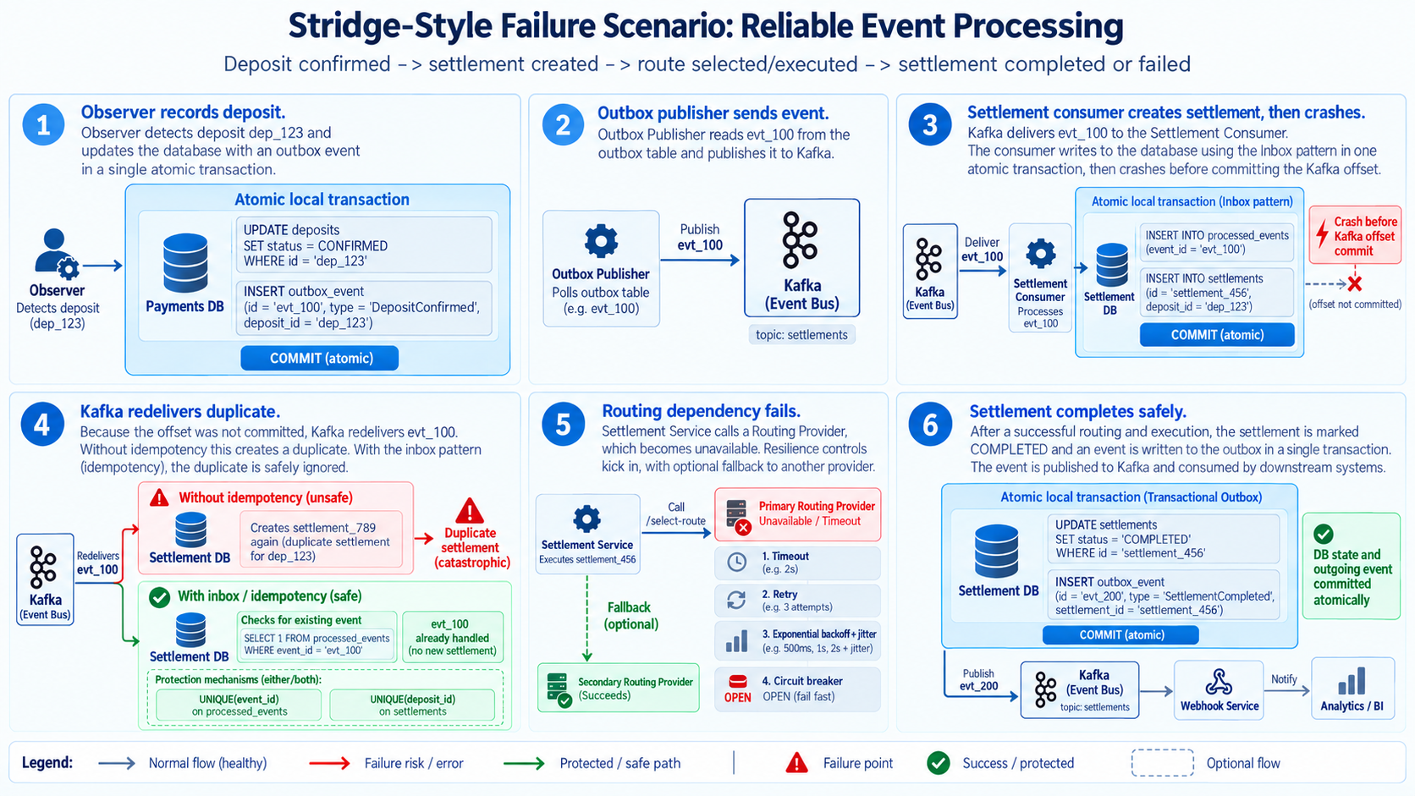
15. Concrete scenario
This diagram is very important read carefully!

16. critical concepts
VERY IMPORTANT: At-least-once delivery means your consumer receivs the event (atomically adds the event to processed events and updates the DB) AND THEN commits received_event (offset) to kafka. The consumer must expect duplicate messages because the offset commit is done after and might crash; therefore, kafka might think the consumer hasn’t processed a specific event.

VERY IMPORTANT: Transactional Outbox prevents the database/event dual-write inconsistency, but consumers still need idempotency because duplicate publication can occur.

